National University of Computer and Emerging Sciences



Section E lab 3

OOP LAB

|  |  |
| --- | --- |
| Name | Muhammad Zain |
| Roll No. | 19F-0228 |
| Lab INSTRUCTOR | Sir Mughees Ismail |
| Semester | Spring 2020 |

# TASK 1:

# Source Code:

#include<iostream>

using namespace std;

int countfunction(int input, int counter = 0)

{

if (input == 0 || input == 1)

{if (counter!=1)

++counter;

return counter;

}

else if (input != 0)

{

input = input / 10;

counter=counter++;

countfunction(input,counter);

}

}

int main()

{

int input,counter=0;

cout << "Enter a number to find its length " << endl;

cin >> input;

cout << "There are total " << countfunction(input, counter) << " digits in value " << input << endl;

system("pause>0");

}

# Snip:

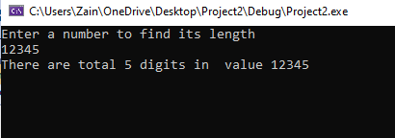

# Task 2:

## Source code;

#include<iostream>

using namespace std;

bool Primerecurrsion(int input, int i = 2)

{

if (input <= 2)

return (input == 2);

if (input % i == 0)

return false;

if (i * i > input)

return true;

return Primerecurrsion(input, i + 1);

}

int main()

{

cout << "Enter a number to check whether it is a prime number or not" << endl;

int input;

cin >> input;

if (Primerecurrsion(input))

cout << "yes ! it is a prime number:-) ";

else

cout << "No !it is not a Prime Number:-( ";

return 0;

}

## Snip;

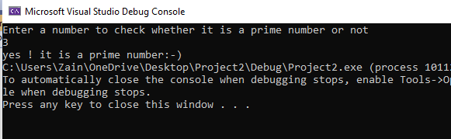

# Task 3

## Source code:

#include <iostream>

using namespace std;

void printNumbers(int input)

{

bool yes = 1;

// Creating a copy of the number

int copy = input;

if (input > 0)

{

while (copy > 0 && yes == 1)

{ int digit = copy % 10;

if (digit != 1 && digit != 3)

yes = 0;

copy = copy / 10;

}

if (yes == 1)

cout << input << " ";

printNumbers(input - 1);

}

}

int main()

{

int input;

cout << "enter a number to print out all the prime number bfore them in a reverse order " << endl;

cin >> input;

printNumbers(input);

system("pause>0");

}

## Snip:

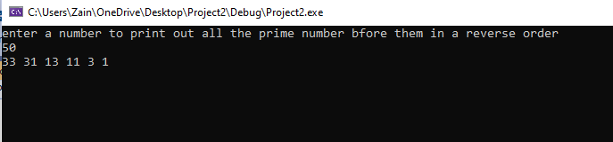

# Task 4

## Source code;

#include<iostream>

using namespace std;

int factorialrecursion(int a)

{

if (a == 1 || a == 0)

return 1;

else

return(a * factorialrecursion (a - 1));

}

int main()

{

int input;

cout << "Input the Number to find its factorial" << endl;

cin >> input;

cout<<"Factorial of "<<input<<" is ="<<factorialrecursion(input);

system("pause>0");

}

## Snip:

